**Getting video out of the camera**

1. over IP via Ethernet

2. over IP via Wi-Fi

3. Direct output

1. **over IP via Ethernet**

Default IP address: 192.168.1.88 , for wired Ethernet

Default user: admin  
Default Password: admin

To connect to the camera over Ethernet you need to manually set an IP address through the network and sharing center properties. (Follow the “webcam ip access guide”)

* 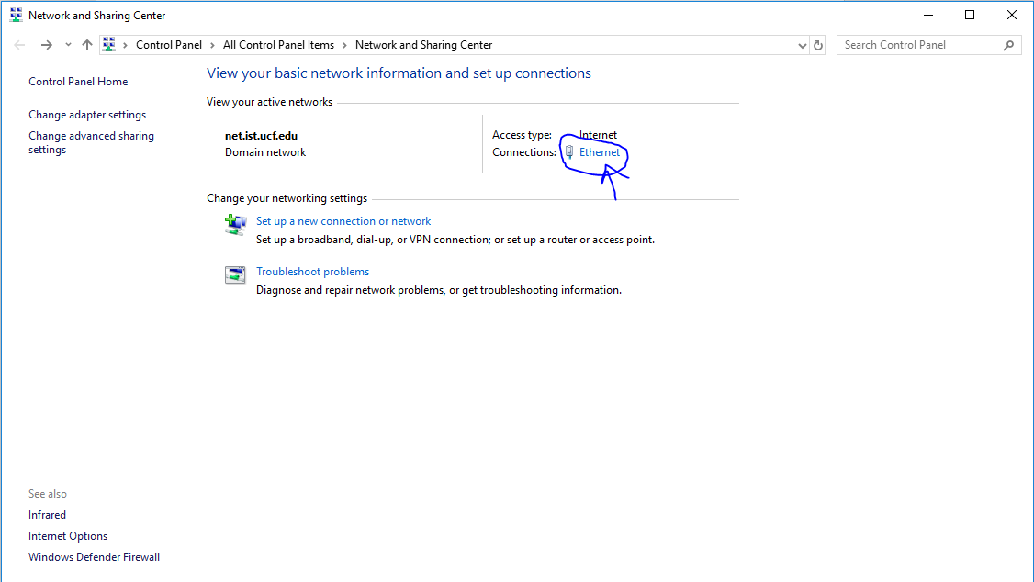click the Ethernet link highlighted, and then properties, then click “Internet Protocol Version 4(TCP/IPv4)” and input the information from the guide

Once the ip address is configured download the activeX webCMS file

(there were issues running the file as it wasn’t verified, we had to disable windows smartscreen to run it)

Then open up internet explorer or edge browser and type the default IP address for Ethernet, 192.168.1.88 into the address bar and press enter.

If configured properly, (make sure the computer is connected via Ethernet as well) a login box should show up.

Type the username “admin” and password “admin” into the dialog boxes and click the left button to access the video over IP feed.

1. **Over IP via Wi-Fi**

Haven’t tested the Wi-Fi modules yet

1. **Direct output**

To broadcast the signal from the camera and board to a monitor, a BNC male to RCA adapter is needed.

The video out from the camera is fed through a BNC female plug. The method we used was a BNC Male to RCA female adapter and then a double male RCA cable to connect to the monitor.

This method had little to no latency compared to the almost 1 second delay from the Ethernet over IP method